

Version 1.01

BIOMETRIC Exit MObile application users guide

Contents

[Installation: 3](#_Toc484089910)

[Logging In: 5](#_Toc484089911)

[Using the Application: 6](#_Toc484089912)

[IPhone: 7](#_Toc484089913)

[Android: 9](#_Toc484089914)

[Refreshing: 11](#_Toc484089915)

[Troubleshooting: 12](#_Toc484089916)

[Login Page: 12](#_Toc484089917)

[Main Page: 13](#_Toc484089918)

[Support Information: 15](#_Toc484089919)

# Installation:

There is no installation needed. To open the Identify application:

1. Make sure you have a browser and internet connection.

Supported browsers:

 C:\Users\EHGDI9E\Desktop\Phone App User Guide\firefox_48x48.png C:\Users\EHGDI9E\Desktop\Phone App User Guide\InternetExplorer.png C:\Users\EHGDI9E\Desktop\Phone App User Guide\safari-ios_48x48.png

1. Enter the following link in your browser’s search bar:

[https://s3.amazonaws.com/bio-sample-app-987452341283/index.html](%20https:/s3.amazonaws.com/bio-sample-app-987452341283/index.html)

C:\Users\EHGDI9E\Desktop\Phone App User Guide\urlBar.PNG

https://s3.amazonaws.com/bio-sample-app-987452341283/index.html

1. Go to the link. [Having trouble with proper verbiage for this]
2. A Login Screen will appear.

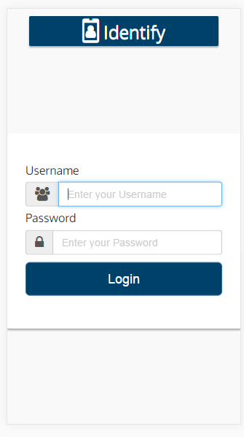

Login Page

# Logging In:

1. Enter Username and Password



1. Press Login and you will be presented with the Main Page of the application.

# Using the Application:

Main Page

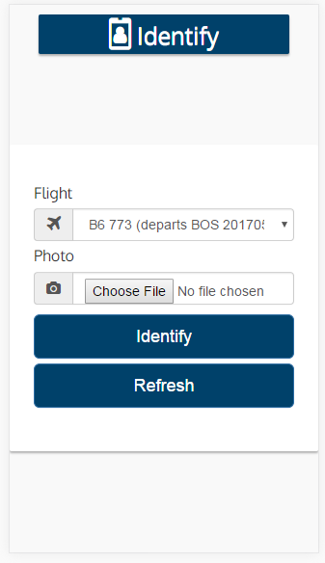

1. Select a flight.

1a. Click the down arrow in the Flight field.

1b. Select a flight from the drop down list.

1c. Flights are listed in alphabetical order by

1. Take a photo.

## IPhone:

1. Rotate the camera 90 degrees clockwise to enter Landscape mode.

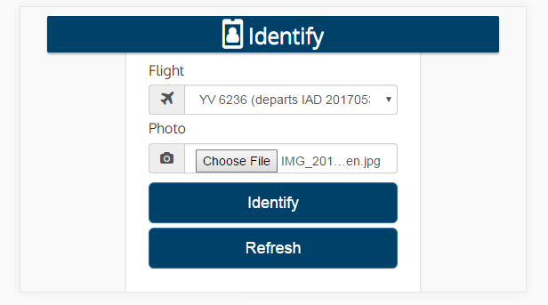

1. 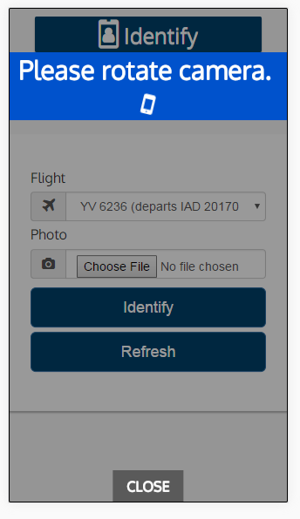Click the “Choose File” button in the Photo Field.

Note: If the camera is still in Portrait view when the button is pressed a warning will inform the user to use Landscape view.

1. Once in Landscape view:
   1. Take Photo: Take a new photo for identification
   2. Photo Library: Use and existing photo
   3. Cancel: Exit photo taking menu.

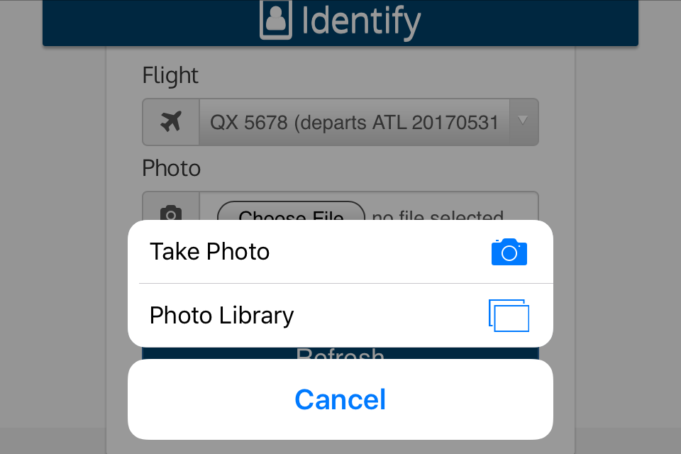

3-1. Take Photo:

1. Once a photo is taken a menu to “Retake” or “Use Photo” will appear.
2. Choose “Use Photo”.

3-2. Photo Library: [Needed instructions]

## Android:

[Needed full instructions]

1. Press the Identify button.
2. Get a result.

Results Page

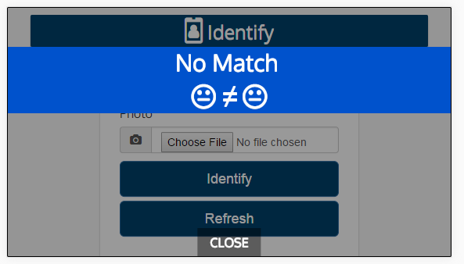

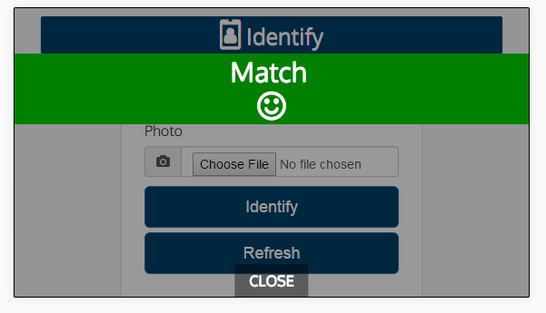

\*You may choose to take another picture by following Steps 1-3.

# Refreshing:

If you want to refresh the main page:



Press Refresh to refresh on the main page.

# Troubleshooting:

Possible Errors

## Login Page:

**Incorrect username and/or password**

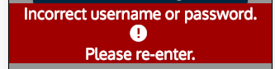

**Cause**: Incorrect user name or incorrect password.

**Fix**: Try re-entering both username and password.

**Invalid Input**

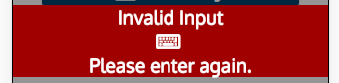

**Cause**: Incorrect user name or incorrect password.

**Fix**: Try re-entering both username and password.

## Main Page:

**All Fields Required**

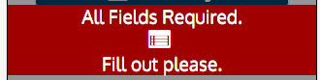

**Cause**: A photo has not been chosen in the photo field.

**Fix**: Try choosing or taking a photo for the photo field.

**Dataset not yet assigned**



**Cause**: - Date of Flight has passed or is perceived to have passed.

- Date of Flight is in the future.

**Fix**: Currently this is bug and is in the process of being fixed.

- If the date has actually passed, a new flight must be created.

- If only perceived, please contact the help desk.

- The Date must be today’s date.

**Failed to decode image**

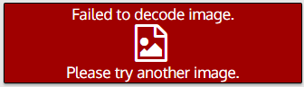

**Cause**: Format of image is incorrect.

**Fix**: Use .jpg, .jpeg files for photos.

**Face not found**

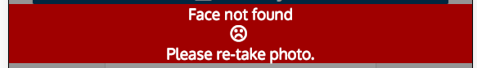

**Causes**: - A face is not in the photo.

**-** The face falls below acceptable criteria.

- A photo was taken in portrait view.

- A photo was taken upside down.

**Fixes**: - Make sure there is at least one face in the photo.

**-** Have person photo to be taken to look directly at the camera and also for adequate light is around for taking pictures.

**-** Turn camera 90 degrees clockwise and it is in Landscape view before taking a photo. The shutter button should be on the left side.

**-** Make sure the shutter button is on the left before taking the photo.

## Support Information:

In the event an issue cannot be resolved by the user, please contact CBP OIT for support using the following methods:

1. For immediate service, please call the TVS duty phone: (703) 258-4249.

*Please have a detailed description of the issue on hand to assist CBP OIT in resolving the issue.*

1. By Email: [TVSSupport@cbp.dhs.gov](mailto:TVSSupport@cbp.dhs.gov)

*You will receive a response within 24 hours.*